# Homework #3: Policy Based Management

|  |
| --- |
| * This is an individual assignment, and is worth 20 points. * The due date is Tuesday, February 6th (2:30 PM sec01; 5:50 PM sec76). * Use the following naming convention: homework, underscore, last name, first initial, and extension (e.g., Homework #3_ImG.docx). If you do not follow the convention, I will deduct 1.0. |

* **(Task1)** Show in a screenshot the condition(s) you created.

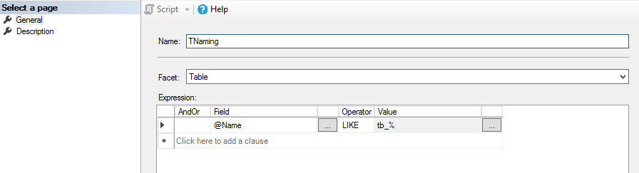

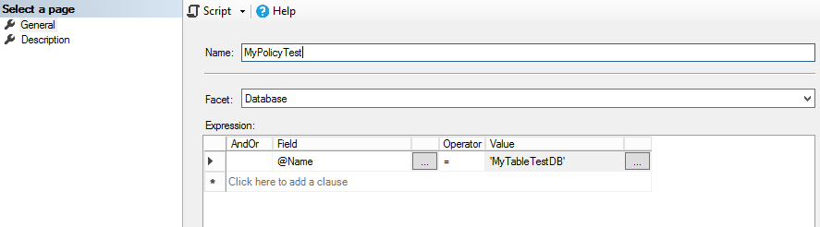

* **(Task2)** Show in a screenshot the policy you created.

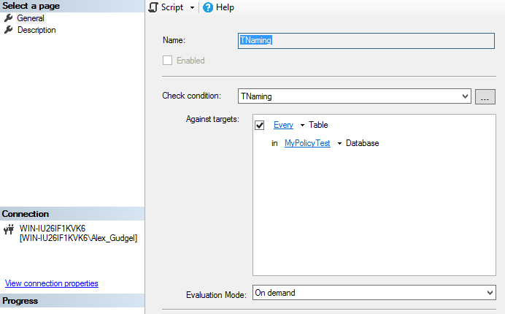

* **(Task3)** Show in a screenshot the test results using the four tables that are provided above.

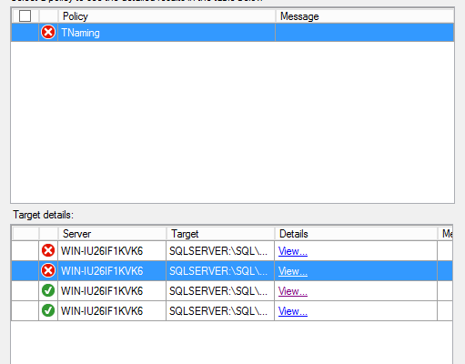

* After this, disable the policy you’ve just created.